FIELD COURSE TAKES STUDENTS TO THE CENTRAL MEXICAN HIGHLANDS

Dr. Miguel de Oliver and Dr. Richard Jones taught a Summer II (2018) course on the social and economic geography of Mexico that included a classroom portion followed by an intensive two weeks in Guanajuato, Puebla, and Mexico City. The primary focus of the field portion of the course was to bring the geography and history of Mexico to life for students—for instance, to venture deep into a Guanajuato silver mine to see how the peones managed, barefoot, to bring 120-pound loads of ore up on their backs; to proceed up the slope of an active volcano and learn how drone-monitoring of its heat and gases is pointing to additional eruptions in the near future, and later to visit a migrant village in Puebla and hear the gripping stories of death at the border; to be punted among the canals and floating gardens of an ancient lake to experience how the Aztecs farmed and ferried people and produce in pre-Columbian Mexico City.

The group of eight undergraduate students and two faculty left July 24th on a circuitous Injerjet flight from San Antonio to León, Guanajuato, with stops in Monterrey and Mexico City, leaving at 11am and arriving at 11pm, only to find that their hotel reservations in downtown Guanajuato had all but evaporated, a victim of the Guanajuato International Film Festival. These things do occasionally happen in Mexico, and the professors being well-versed in such happenings, took this in stride and arranged alternate lodging for some of the party until the faux pas could be worked out the next morning with the hotel manager. This was the first of what were to be many adventures.

Guanajuato is a bowl filled with jewels, a topographic basin with churches, balconied inns and businesses, the rising ramparts of the University of Guanajuato, and multi-colored homes---all strung together by streets and callejones (pedestrian alleyways) interspersed with green plazas and jardines. Four hundred years ago this valley was occupied by 50 haciendas vying for control of the richest silver vein in the world, the Veta Madre, running high along one lip of the bowl. On their first day in the city, the group surveyed this scene, ascending the opposite lip of the bowl, up to the El Pípila monument---honoring the miner who in 1810, with a slab of stone on his back as protection against Spanish guns above, ascended to the door of the Alhondiga (granary) and burned it down, allowing the peasant army of Manuel Hidalgo to stream in and kill all of the gauchupines ensconced inside---the first battle for Mexican Independence. The same day, the group visited the ex-Hacienda San Gabriel de Barrera, the most famous of the early haciendas, with its patio for separating the silver from the ore, and its ornate mansion where the guide painted a picture of the patriarchal, racially-stratified society that held sway until Independence swept away the Spanish---only to install a Mexican creole society in their place. Both the Alhondiga and the hacienda emphasized various observations and questions that were points of discussion in the classroom. The second day in Guanajuato saw the group on the slope of a nearby mountain, where they were treated to an ecological farming and reforestation project, and from where they descended on bicycles to the outskirts of the city. On the third day the students were exposed to early-morning lectures on the architecture of Guanajuato and the role of water in the economic geography of the Bajio and adjacent highlands, given by an architecture professor and a geography professor, respectively, from the University of Guanajuato. Afterwards, the group entered a silver mine, San Cayetano, and then was led by the geography professor up to the Cristo Rey de Cubilete, a church and pilgrimage site for Catholic faithful from across the country; they then descended into the Bajío, specifically the Puerto Interior, a large industrial park in Silao for TNCs such as Magna, VW, Primera Plus, Nishikawa, etc. The geography professor gave professional insights on sustainability issues---reforestation as well as the sustainability of commercial agriculture and water extraction in the Bajio---that were appreciated by the students. They emphasized sustainable development---the core of our program of Geography and Environmental Sustainability. The fourth day in Guanajuato was spent in nearby San Miguel de Allende, at the ecological farm known as Via Orgánica, and it was similarly appreciated by the students. The mission of this farm is to educate local students, international visitors, and local farmers in the practices of raising pesticide-free vegetables, free-grazing chickens, and various edible cacti. Organic fertilizers are produced using worm-composting and aromatic flowers are raised for pollination. The produce from the operation supplies the Via Orgánica Restaurant in San Miguel (where we ate lunch), which is patronized by the large American retirement community there. Our final full day in the Guanajuato area found us at a Classical Otomí ceremonial center, Canyon de la Virgen, under the tutelage of a dynamic guide and archaeologist whose description of the astronomical orientation of the center, its role as an ancient pilgrimage destination and school, and the burials found at the site, were consummately fascinating.

Unlike the Guanajuato portion, the Puebla portion of the field course was a “package,” including slide presentations by UPAEP professors; guides; lodging; meals; and transportation---organized by the head of short-term international student programs at the Popular Autonomous University of the State of Puebla (UPAEP). Arriving at UPAEP late on July 30th by a series of taxis and buses, we were put up in university dorms for the three nights of our stay. Our first day in Puebla took us along a jarring road up the slopes of yet another mountain, this time the active Volcano Popocatepetl (17,000 ft. +), with the professors joking about making sacrificial victims of any complaining students. This adventure (fortunately no students misbehaved) was followed immediately by a guided tour of Cholula, the prehistoric pyramid near Puebla that is the largest in volume in the world. Benefited by another excellent, and sympathetic, guide, we questioned why this gem (and the nearby temples and burial grounds) has not been fully excavated, to learn that it has much to do with the Catholic church that graces its summit. Again, this was relevant to the classroom portion of the course, where we discussed the church’s role in the development or underdevelopment of colonial Mexico. Our final day in Puebla carried us 100km north to Preciosita, a village that provided a unique window on poverty, US migration, and how one village has responded to this migration---all extended topics of the course. Three viejitas (older women) gave harrowing accounts of the hazards and personal tragedies faced by their sons and daughters, nieces and nephews, and spouses in their attempts to cross the border and work in the United States. One of these women showed us yet another example of organic agriculture (swine biogas, worm composting, native plant medicines), funded by UPAEP and US/Mexican foundations, with the express aim to stop US migration from their town. A high point of the Puebla portion was the piñata celebration and gift-giving to the children of Preciosita, that made a lasting impression on the students for its spontaneity and uniqueness.

The field course finished with three days in Mexico City---another high point not least because we stayed in a towering hotel in the Zona Rosa, with a view of the new (earthquake-proof) skyscrapers that now embellish the skyline along the Paseo de la Reforma. The first morning we strolled along Insurgentes Ave. to Chapultepec Castle---a magnet since prehistoric times, the home of Mexican presidents until the 1930s, but most famous for what happened there in September 1847 as US troops were advancing on the Castle at the end of the US/Mexican War. Six cadets of the military academy at the Castle refused their commander’s order to retreat, preferring to die there instead; one (Juan Escutia) is believed to have wrapped himself in the Mexican flag before plummeting to his death from the cliff face that surrounds the castle. We dwelled for some time at the statues and monuments to Los Niños Heroes, honored throughout Mexico. After visiting the castle, our party walked to the famous Anthropology Museum in another part of Chapultepec Park. On the second day of our stay in the D.F. (Distrito Federal) we began the day at the Casa Azul, the home of Frida Kahlo and Diego Rivera that is now a museum devoted to the life and work of Frida. On this day we also took a launch (trajinera) on lake Xochimilco in the southern part of Mexico City, described in the first paragraph. It provided an immersion into Mexican history and popular culture not experienced elsewhere on the trip. One student took this a little too far, with a spontaneous dip in the canal. Our final day in Mexico City was marked by a relatively uneventful subway journey to the main downtown plaza (the Zócalo) with visits to the Cathedral, the National Palace, and (a few blocks away) the Palacio de Bellas Artes.

The group returned to San Antonio early on August 6th. The course culminated with the final exam and presentations by student duos on major questions raised during the field portion of the course.

Below are two students’ comments on what the course meant to them:

The Guanajuato-Puebla study abroad course summer 2018 was a life changing experience. Studying abroad in Mexico opened my eyes to the importance of stepping out of my comfort zone, where I learned so much about myself, others and the world. Being immersed into Mexican society was so amazing, traveling to different cultural sites, museums and experiencing life in a different culture is the best way to learn about it. After this trip I have made life long relationships with my classmates’ and professors, I appreciate the diversity of cultures, and have become a world traveler.

The trip had a lasting effect on my perception of Mexico as well as my perception of the United States. Through hearing stories about low factory wages or treacherous journeys across the border, I obtained a more complete understanding of the hardship of the Mexican people, especially those in rural areas, compared to the average US American. The Mexican people, despite their lower rung on the economic world ladder, were exceedingly friendly and generous. We were welcomed in and fed in several homes during our stay. Overall my experience left me with a great admiration for the people of Mexico.

PHOTOS

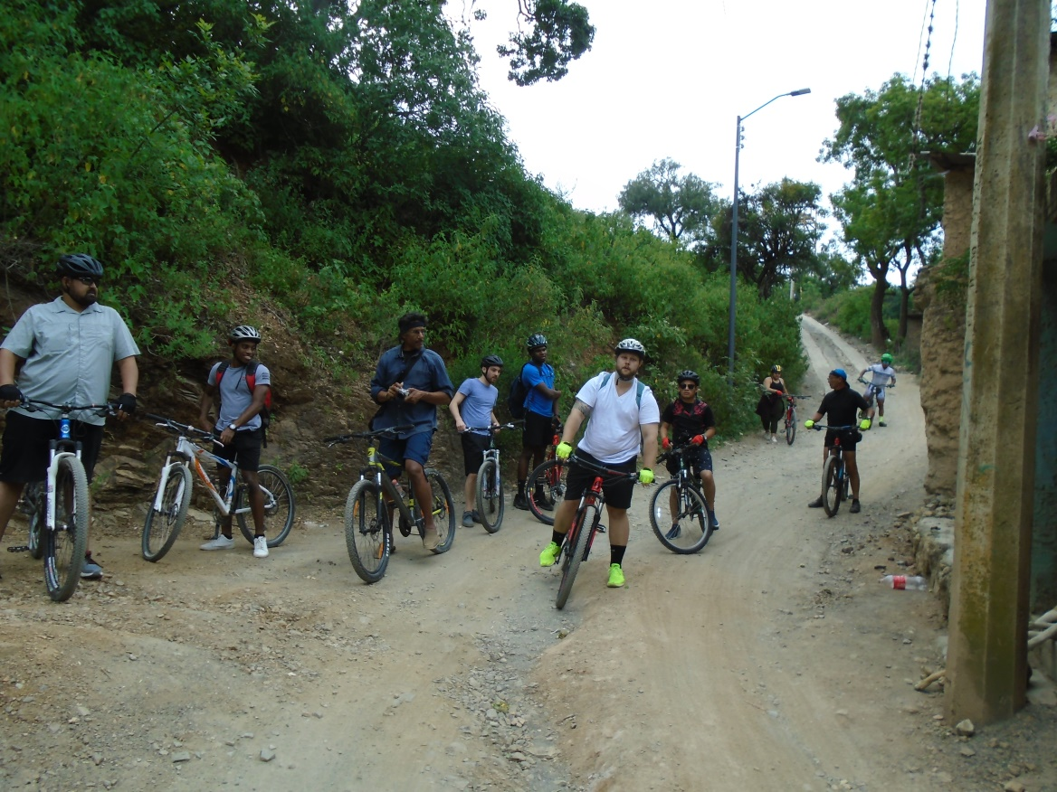
Bicycle excursion, Guanajuato

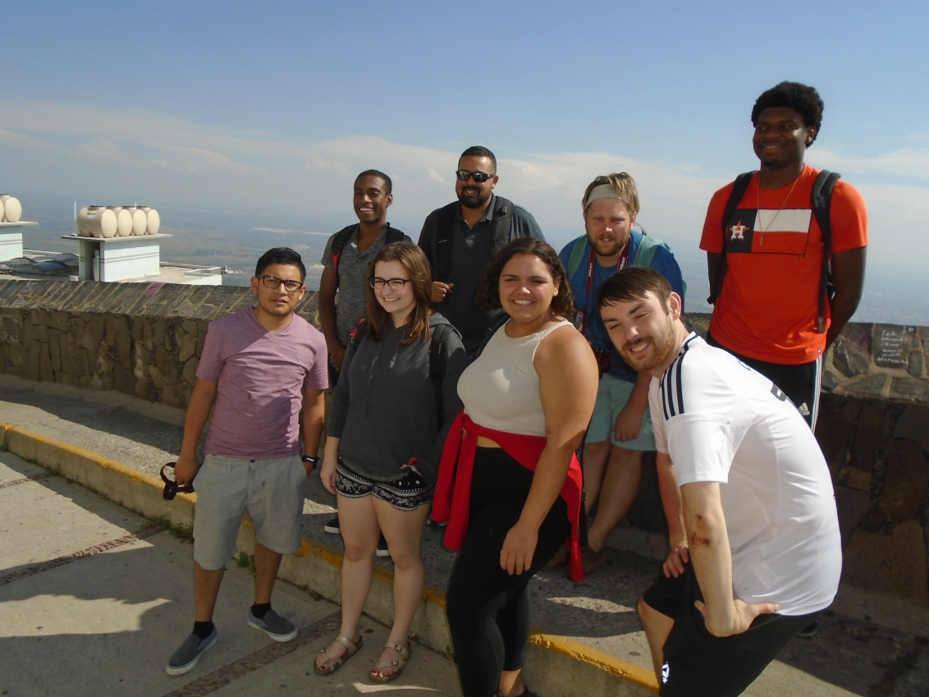
Cubilete
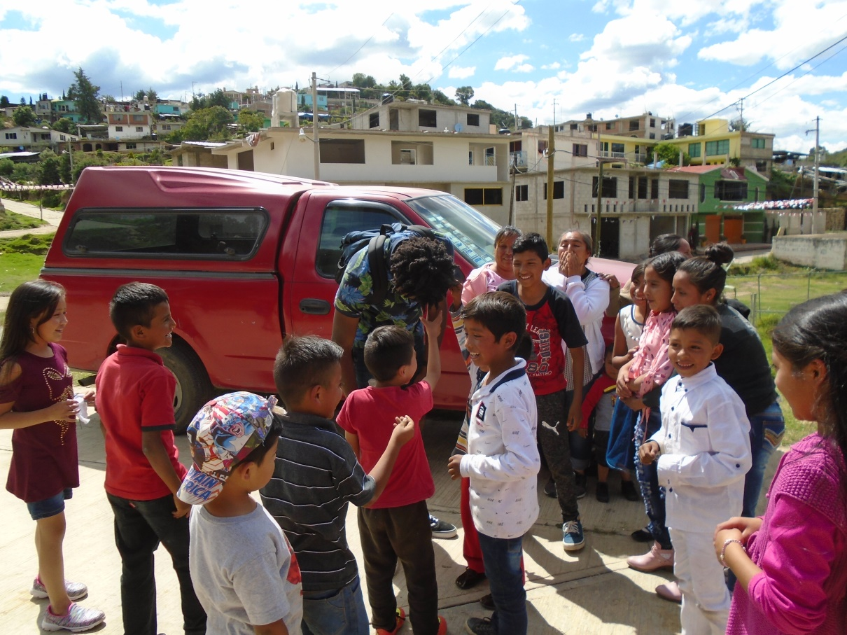
Preciosita

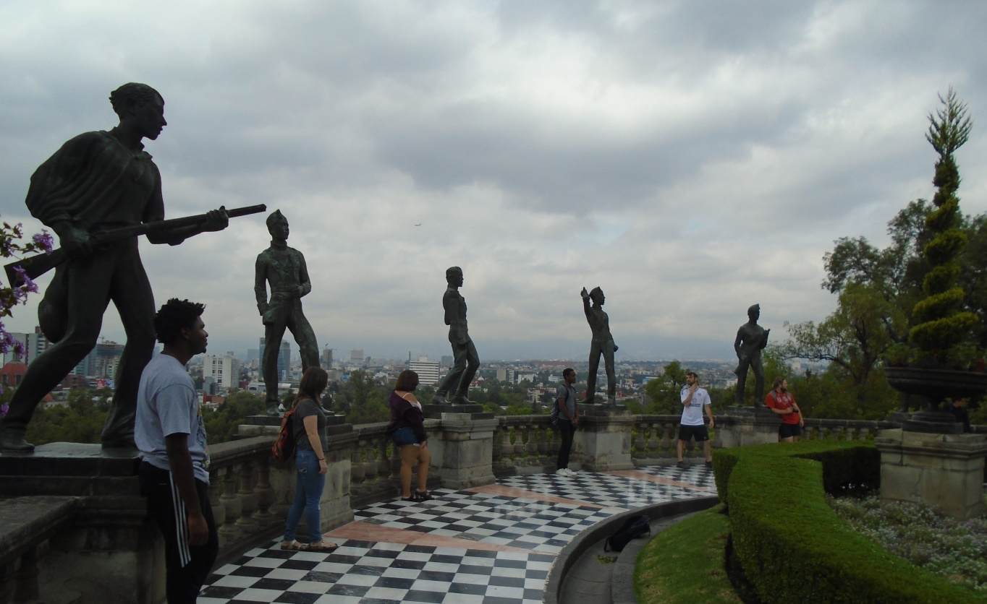
Los Niños Heroes

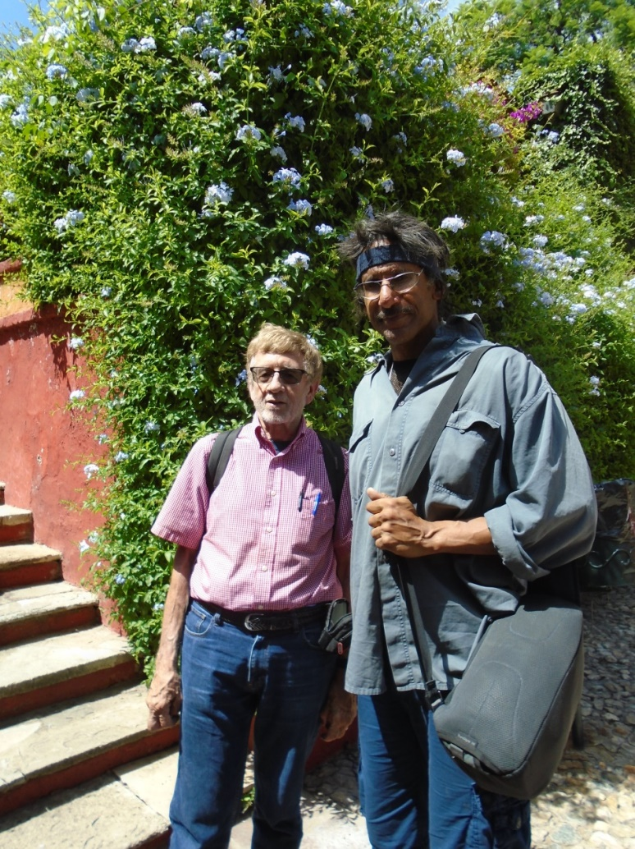
Los Profesores Heroes

